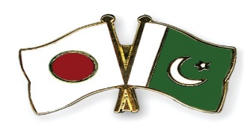
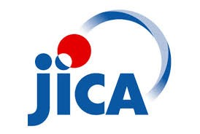

The Project for Skills Development and Market Diversification
of Garment Industry in Pakistan
under Japan International Cooperation Agency (JICA)
Public Private Partnership Task Force for Marketing Strategy
Presents

JICA Apparel Export Workshop#2
- Developing International Branding and Design –

- “Developing International Brand from Bangladesh”

2. “Creating Attractive Design for International Market”

Date: November 16th, 2017 (Thu) 2:30pm-5:30pm.
Venue: “Indus2”, Avari Towers, KARACHI

JICA’s Apparel Industry Support Project (The Project of Skills Development and Market Diversification of Garment Industry in Pakistan) would like to organize 2nd Apparel Export Workshop, sponsored by Ministry of Textile Industry and TDAP. This workshop will tell you how to develop international branding and design based on success stories of Japanese specialists. The attendance is free. Don’t miss this opportunity!

The outline/program of the workshop is as follows:
2:00 pm: Registration of Participants

2:30 pm: Opening Remarks by JICA PSDMD Team
Speech by Trade Development Authority of Pakistan (TDAP)

3:00 pm: Lecture on “Developing International Brand from Bangladesh “
by Ms. Eriko Yamaguchi, CEO/Designer, Motherhouse Co., Ltd.

4:00 pm: Lecture on “Creating Attractive Design for International Market”
by Ms. Hiroko Ito, Designer

5:00 pm: Refreshments
Co-organized by Ministry of Textile Industry, TDAP

Kindly fill the Registration Form as attached and send through email (written below) for your participation.
Profile of Lecturers
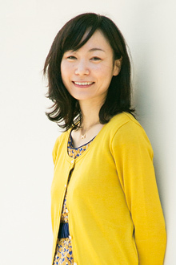
Ms. Eriko Yamaguchi
CEO&Chief Designer, Motherhouse Co., Ltd.

Ms. Eriko Yamaguchi is a young and aspiring international entrepreneur and a designer who established her own famous brand called “Motherhouse” starting her business in Bangladesh, and expanding her business as the top management of her own company in Japan that actually conducts multi-nation operations.
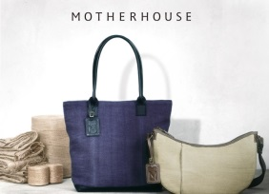
The purpose of inviting Ms. Eriko Yamaguchi is to show her business model to Pakistani executives in apparel sector as one of success stories of creating new brand from Bangladesh, one of the poorest developing nations of Asia.

Ms. Hiroko Ito
Designer, “HISUI”

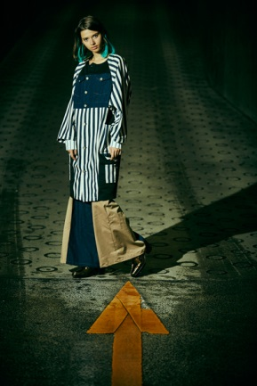
Ms. Hiroko Ito is an experienced fashion designer who established her own fashion brand of “HISUI” in Japan. Her brand items started entering China market recently. She graduated from NY Fashion Institute of Technologies (FIT), and also has international experiences and network.
The purpose of inviting Ms. Hiroko Ito is to tell Pakistani how to create attractive fashion design as well as suggestion on Pakistani fashion products which may well have competitiveness and strength in the global market.

Registration Form for Participation

JICA Apparel Export Workshop
Date: November 16th, 2017 (2:30 pm to 5:30 pm)
Place: Avari Towers, Karachi
Venue: Indus2

Name

Company | Company Name:  Position: Products:
Contact | Tel: Fax:  E-mail: Cell:
The deadline for the registration is November 10, 2017.

Contact for Registration:
Muhammad Asim Khan
P.A to JICA Advisor, Trade Development Authority of Pakistan (TDAP)
Cell No. 0301-2705380
Email: asim.khan@tdap.gov.pk

Contact:
Mr. Muhammad Asim Khan
Personal Assistant to JICA Advisor,
Trade Development Authority of Pakistan (TDAP)
Block-A, 3rd Floor, FTC Building, Shahrah-e-Faisal, Karachi.
Ph: 0301-2705380 Email: asim.khan@tdap.gov.pk

